Prototype
(Creational)

A prototype is a template of any object before the actual object is constructed. The prototype design pattern is used in scenarios where an application needs to create a number of instances of a class that have almost the same state or differ very little.
The prototype pattern is a creational design pattern in software development. It is used when the type of objects to create is determined by a prototypical instance, which is cloned to produce new objects.
In the prototype design pattern, an instance of the actual object (i.e., prototype) is created in the beginning, and thereafter, whenever a new instance is required, this prototype is cloned to have another instance. The main advantage of this pattern is that it has a minimal instance creation process, which is much more costly than the cloning process.
Suppose a user creates a document with a specific layout, fonts, and styling, and wishes to create similar documents with slight modifications.

Design Participants
- Prototype Interface or Abstract Class
  - This defines the method for cloning objects and sets a standard that all concrete prototypes must follow. Its main purpose is to serve as a blueprint for creating new objects by outlining the cloning contract.
  - It includes a clone method that concrete prototypes will implement to create copies of themselves.
- Concrete Prototype
  - This class implements the prototype interface or extends the abstract class. It represents a specific type of object that can be cloned.
  - The Concrete Prototype details how the cloning process should work for instances of that class and provides the specific logic for the clone method.
- Client
  - The Client is the code or module that requests new object creation by interacting with the prototype.
  - It initiates the cloning process without needing to know the specifics of the concrete classes involved.
- Clone Method
  - This method is declared in the prototype interface or abstract class and outlines how an object should be copied.
  - Concrete prototypes implement this method to define their specific cloning behavior, detailing how to duplicate the object’s internal state to create a new, independent instance.

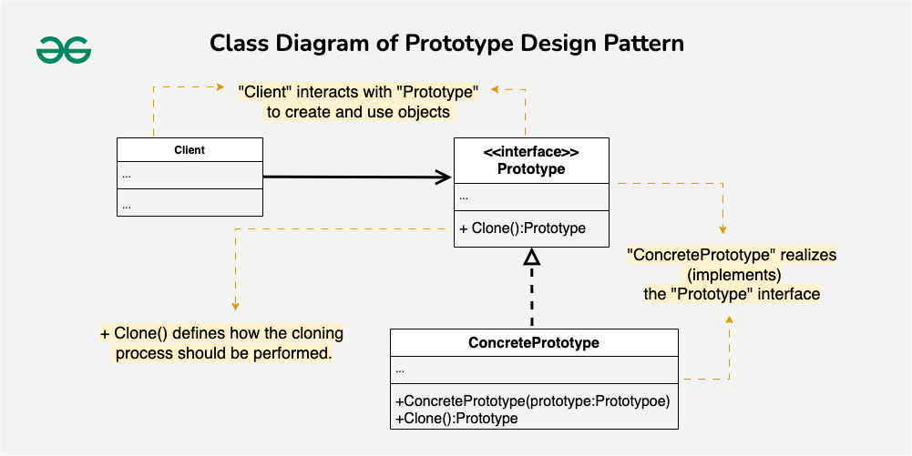
Prototype Design Pattern example
Imagine you’re working on a drawing application, and you need to create and manipulate various shapes. Each shape might have different attributes like color or size. Creating a new shape class for every variation becomes tedious. Also, dynamically adding or removing shapes during runtime can be challenging.
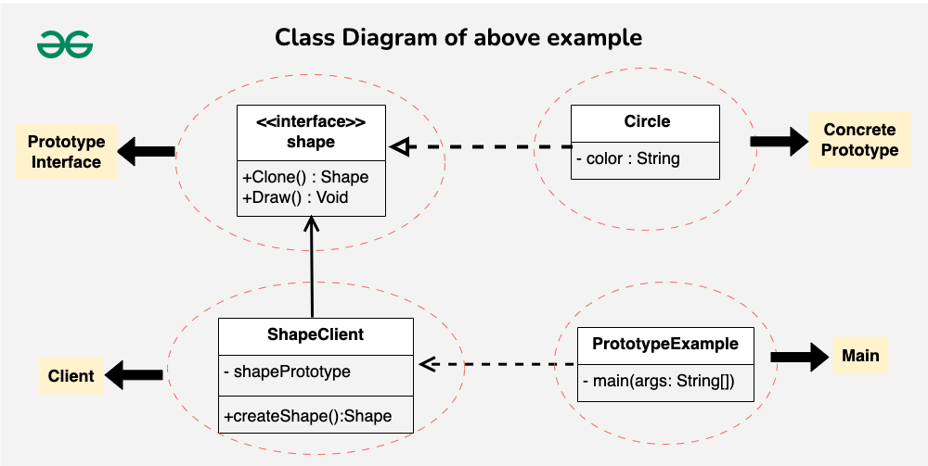

1. Prototype Interface (Shape)

// This is like a blueprint for creating shapes.
// It says every shape should be able to clone itself and draw.
public interface Shape {
Shape clone(); // Make a copy of itself
void draw(); // Draw the shape
}

2. Concrete Prototype (Circle)

// This is a specific shape, a circle, implementing the Shape interface.
// It can create a copy of itself (clone) and draw in its own way.
public class Circle implements Shape {
private String color;

// When you create a circle, you give it a color.
public Circle(String color) {
this.color = color;
}

// This creates a copy of the circle.
@Override
public Shape clone() {
return new Circle(this.color);
}

// This is how a circle draws itself.
@Override
public void draw() {
System.out.println("Drawing a " + color + " circle.");
}
}

3. Client (ShapeClient)

// This is like a user of shapes.
// It uses a prototype (a shape) to create new shapes.
public class ShapeClient {
private Shape shapePrototype;

// When you create a client, you give it a prototype (a shape).
public ShapeClient(Shape shapePrototype) {
this.shapePrototype = shapePrototype;
}

// This method creates a new shape using the prototype.
public Shape createShape() {
return shapePrototype.clone();
}
}

4. Main class

public class PrototypeExample {
public static void main(String[] args) {
// Create a concrete prototype (a red circle).
Shape circlePrototype = new Circle("red");

// Create a client and give it the prototype.
ShapeClient client = new ShapeClient(circlePrototype);

// Use the prototype to create a new shape (a red circle).
Shape redCircle = client.createShape();

// Draw the newly created red circle.
redCircle.draw();
}
}

Output:
Drawing a red circle.
Resources:
https://www.geeksforgeeks.org/prototype-design-pattern/
https://howtodoinjava.com/design-patterns/creational/prototype-design-pattern-in-java/

